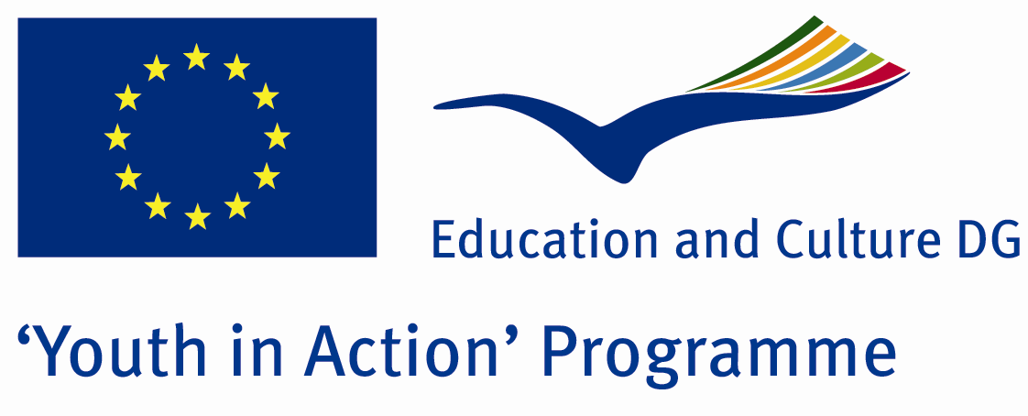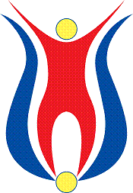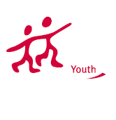

Action 1.1
Project Summary; Would you like to have new ideas about turizm in one of the most beautiful cities of our country that is on its way to become the center of turizm in Europe? To have ideas about various hotels and organizations working on turizm and to come up with new ideas related with your countries, our project will be a unique opportunity.

Project Title; Secrets of Tourism
Date and Venue ; 01-08 2013 March Turkey
Place: Yalova.

Target Group ; Municipalities, City Councils and Non-Governmental organizations,
youth groups,culture and art groups,e.t.c

Participants ; 5 people from each country (over 18 -25 ). Totally 7 countries.

Conditions ; Accommodation, board and programme costs will be financed through European Commission Youth in Action Programme . Travel costs will be reimbursed in 70% (APEX Tarrifs). Organizations from all 27 EU member countries plus Liechtenstein , Norway and Iceland are eligible to take part.

Working language: English

Organisator group: Group Tourism Lovers

How to apply: If you are interested, please send your Part III forms to
by e-mail please (in word file). Scan Part3 format is enough for application.(Fulfilled Part III which you can find in the attachment, of course signed and stamped) ..

Contact e-mail: groupsymrnes@gmail.com
Group e-mail: tourismlovers81@gmail.com

Deadline to apply:20.09.2012

